Its important to understand Functional Dependencies I order to normalise data!
A > B (A determines B)
B is functionally dependant an A
(i.e if you know the value of A, there can be only one value for B)
customer_id > name
If you have a customer_id can you find the name of a customer? Yes!
600 > Joe Bloggs
But could you identify a single customer_id if you had the name Joe Bloggs? No
There could be lots of Joe Bloggs in the database!
Joe Bloggs > 600, 567, 457
A functional dependency means if you know the value of A you will know the value B.

Attributes
order_id
Can you find the order_date from the order_id? Yes
order_date
Can you find the customer_id from the order_id? Yes
customer_id
name
address
product_id -
Can I find a single product_id from the order_id?
No, an order can have multiple products on it !
So there is no functional dependency!
The same can be said for other details of a single product!
description
finish
price
quantity
This refers to the specific quantity of a single product, not the quantity of all the products on the order, so it has to do with a product not an order
Working back the way!
If you know the order_date can you tell the order_id? No, a date is just a date!
Dates determine nothing except dates!
Next customer_id
Can I find the order_id from the customer_id?
No, a customer can place many orders!
Will I know the name of a customer from the customer_id? Yes same for address.
Will I know a single product_id from customer_id?
No customers can get many products, same for description, finish, price, quantity.
If I know the name of a customer will I be able to tell another other attribute?
No!, there could be customers with the same name.
Same for address, there could be customers with the same address.
If I know the product_id can I find the order that product is on? No, the same product could be on many orders, same goes for order_date, customer_id, name and address.
Will I know description, finish, price? Yes
How about quantity?
If we are talking about stock , then yes, however we are talking about quantity of a single product on a single order so order_id and product_id determine quantity in this case.
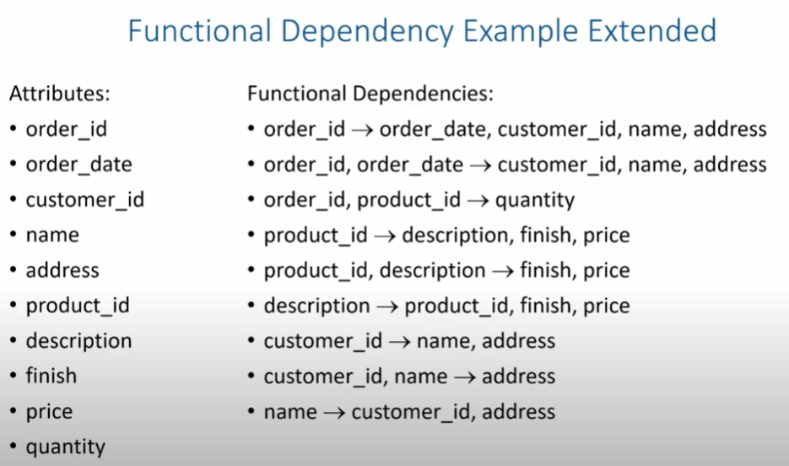

Possible primary keys (candidate keys) are on the left, they will not be keys if they are on the right also.
Anything on the left that is not on the right becomes a primary key

order_no
order_date
customer_no
customer_name
customer_address
customer_address
customer_town
customer_county
customer_postcode
product_id
product_desc
product_quantity
product_price
product_amount
publisher_name
publisher_address
order_total

